**Practical – 3**

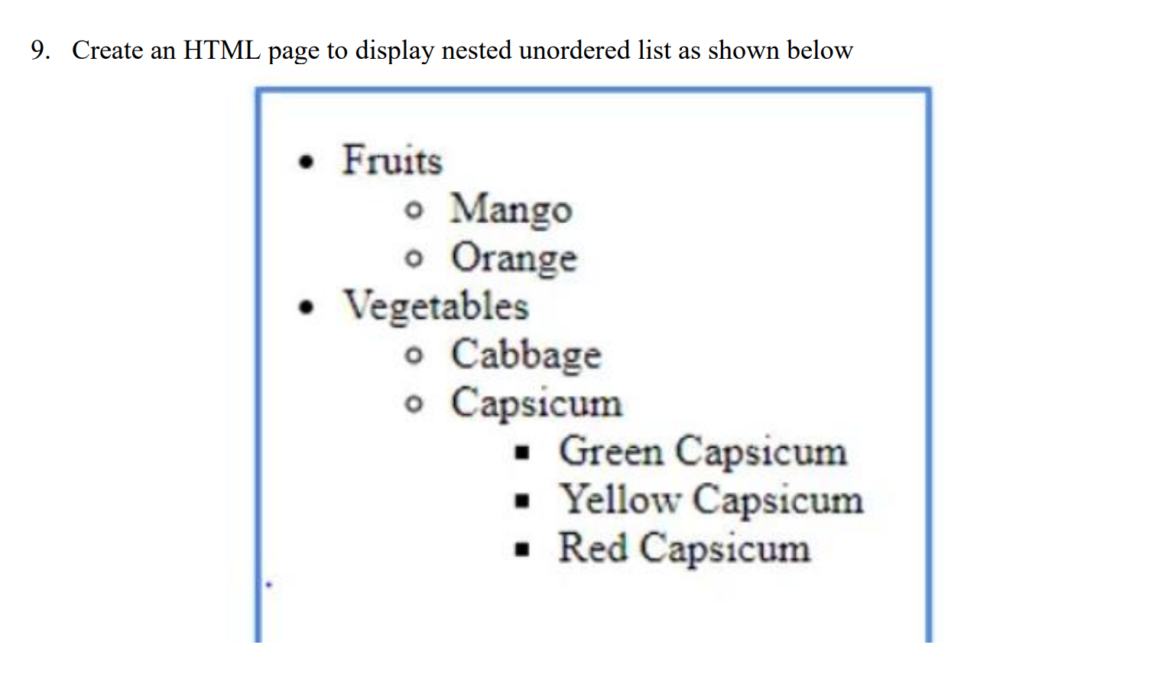

**HTML Code**

<!DOCTYPE html>

<html lang="en">

<head>

<meta charset="UTF-8">

<meta name="viewport" content="width=device-width, initial-scale=1.0">

<title>Rowspan & Colspan </title>

</head>

<body>

<ul type="disc" style="border: 2px solid blue; width: 230px;">

<li>Fruits

<ul type="circle">

<li>Mango</li>

<li>Orange</li>

</ul>

</li>

<li>Vegetables

<ul type="circle">

<li>Cabbage</li>

<li>Capsicum

<ul type="square">

<li>Green Capsicum</li>

<li>Yellow Capsicum</li>

<li>Red Capsicum</li>

</ul>

</li>

</ul>

</li>

</ul>

</body>

</html>

**Output**

